Given the root of a binary tree, construct a **0-indexed** m x n string matrix res that represents a **formatted layout** of the tree. The formatted layout matrix should be constructed using the following rules:

* The **height** of the tree is height and the number of rows m should be equal to height + 1.
* The number of columns n should be equal to 2height+1 - 1.
* Place the **root node** in the **middle** of the **top row** (more formally, at location res[0][(n-1)/2]).
* For each node that has been placed in the matrix at position res[r][c], place its **left child** at res[r+1][c-2height-r-1] and its **right child** at res[r+1][c+2height-r-1].
* Continue this process until all the nodes in the tree have been placed.
* Any empty cells should contain the empty string "".

Return *the constructed matrix* res.

**Example 1:**

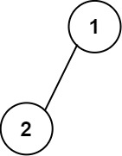

Input: root = [1,2]  
Output:   
[["","1",""],  
 ["2","",""]]

**Example 2:**

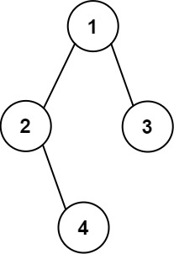

Input: root = [1,2,3,null,4]  
Output:   
[["","","","1","","",""],  
 ["","2","","","","3",""],  
 ["","","4","","","",""]]

**Constraints:**

* The number of nodes in the tree is in the range [1, 210].
* -99 <= Node.val <= 99
* The depth of the tree will be in the range [1, 10].